**Presentation Document**

**Jiarui Hu**

* Instruction:

This application is for tracking weather information of cities in worldwide. Users can get the weather forecast information in next 2-5 days of the input location.

The input fields are in the top of the web page. Users can input the city’s name or zip code, and the number of days of weather forecast, and then the Map on the right side will locate the point that the city located and the information in next several days of this location will show up on the page.

Also, users can check the weather information on specific date on tag content by clicking on specific date on the head line. And user can also add some tips on the right side as Sticky Notes. The data will be stored in local storage.

* Problem Statement:

Nowadays, there are multiple websites providing the weather forecast information for users, but seldom can provide a brief web application for searching weather information for multiple locations in next few days that users can select.

Also, this “City Weather Forecast” adds Sticky Notes for users to write down any tips or to do list on that day, according to the weather forecast. Moreover, there is a google map api on the web so that the users can view the location where they want to check the weather information.

* Application GUI Layout:

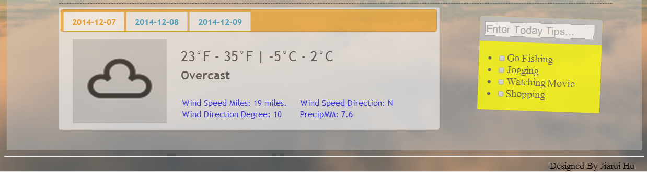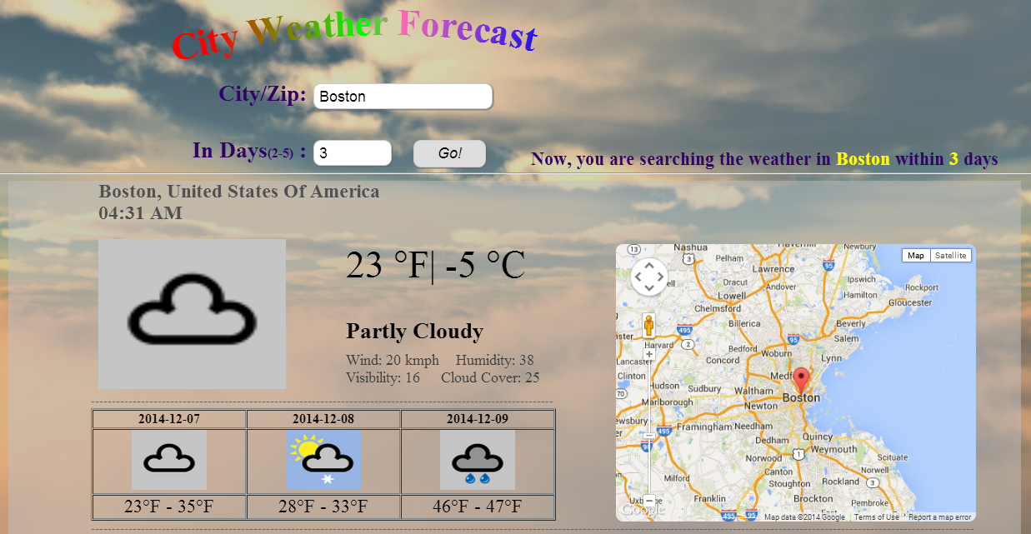

GUI Element: Head, Foot, Table, Jquery UI Tag, etc.

* Services interact with:

I use the services from World Weather Online’s weather API (application programming interface), which allows developers and programmers to access current, past and future weather data for use in apps and on websites.

Their weather API provides local weather, including wind speed, humidity, visibility, cloud cover, icon url, wind direction, etc. Weather can be searched for using a variety of information, including postcode, latitude and longitude, and city’s name.

* Data format:

Their weather API is easy to use and delivers advanced, in-depth weather information. This data is delivered using standard HTTP requests, with their weather API returned in standard industry formats like XML and JSON.

Api call: http://api.worldweatheronline.com/free/v1/weather.ashx?q={zipcode/city name}

&num_of_days={number of days}

api key is 4925da30d1aa95a1460e52de2c833d6c18fbba28.

The response format is XML File. And I use X2JS to convert XML to JSON, fetching data from API to front end as JSON object.

